What will we be learning?  Unit R181 – Applying the principles of training – fitness & how it affects skill performance  TOPIC AREA 1 – Components of fitness applied in sport | Why this? Why now?  This unit is a compulsory coursework unit for the Sport Science course. This unit is taught in Year 10 as it is the largest of the unit and you will have more time to study the unit in depth. This unit has a practical element too. | Key Words:  Cardiovascular endurance  Stamina  Speed  Strength  Power  Agility  Balance  Flexibility  Coordination  Reaction time  Normative data  Validity  Reliability
What will we learn?
TOPIC AREA 1
1.1 Relevance of components of fitness to different sports
    - Definition of, and suitable fitness tests used, to measure each component of fitness
    - Fitness components requirements of sports
    - Justification of most important components of fitness

  - Assess components of fitness
    - Fitness tests for components of fitness
    - Collect and interpret the results of fitness
    - Strengths and areas for improvement of each fitness component

  - Application of components of fitness to skill performance
    - Devising skill-based fitness tests
    - Conduct the tests devised
    - How to record results of skill-based fitness test
What opportunities are there for wider study?
Sixth form studies
- Cam Tech Sport
- A level PE
Careers/degree courses
- Sports science
- Physiotherapy
- PE teacher
How will I be assessed?
- Set OCR assignments under teacher supervision
CAM NAT – SPORT SCIENCE
UNIT R181 – TOPIC AREA 1

1.1 RELEVANCE OF COMPONENTS OF FITNESS APPLIED IN SPORT  1.1.1  - Components of fitness:  - Cardiovascular endurance/stamina  - Muscular endurance  - Speed  - Strength  - Power  - Agility  - Balance  - Flexibility  - Coordination  - Reaction time  1.1.2  - How each component is important in 2 different sports  1.1.3.  - The 2 most important components in each of 2 sports  - In a pressured drill to show how these 2 fitness components relate to effectiveness in a competitive situation | 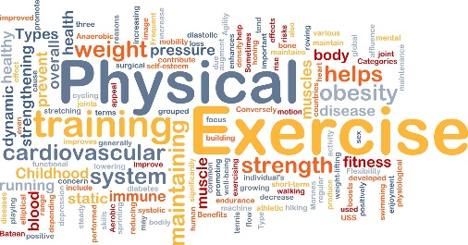  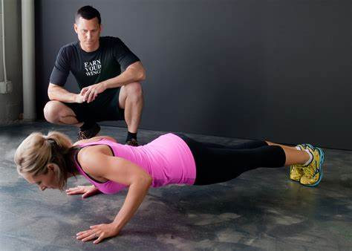
1.2 ASSESS COMPONENTS OF FITNESS
1.2.1
- Fitness tests for components of fitness in 1.1.1

1.2.2
- Collect and interpret results of tests:
  - Against normative data
  - Validity
  - Reliability

1.2.3
- Strength and area for improvement of each fitness component

1.3 APPLICATION OF COMPONENTS OF FITNESS TO SKILL PERFORMANCE  1.3.1  - Devising skill-based fitness tests  - Realistic to a full performance situation  - Procedures  - How to record results  1.3.2  - Conduct the tests devised  1.3.3  - How to record results of skill-based fitness tests and using the appropriate units | 